Report C1

Reasoning

I defined < and <= in for the Rectangle. Firstly, we need to compare the area of the Rectangle, but the compiler could not know its semantic meaning. Therefore, I defined < as an approach to let the compiler know what the actual comparison is.

Meanwhile, I defined <= as well, since in the merge_sort, the circumstance when the left_half[left_half_index] == right_half[right_half_index] is included in the else.

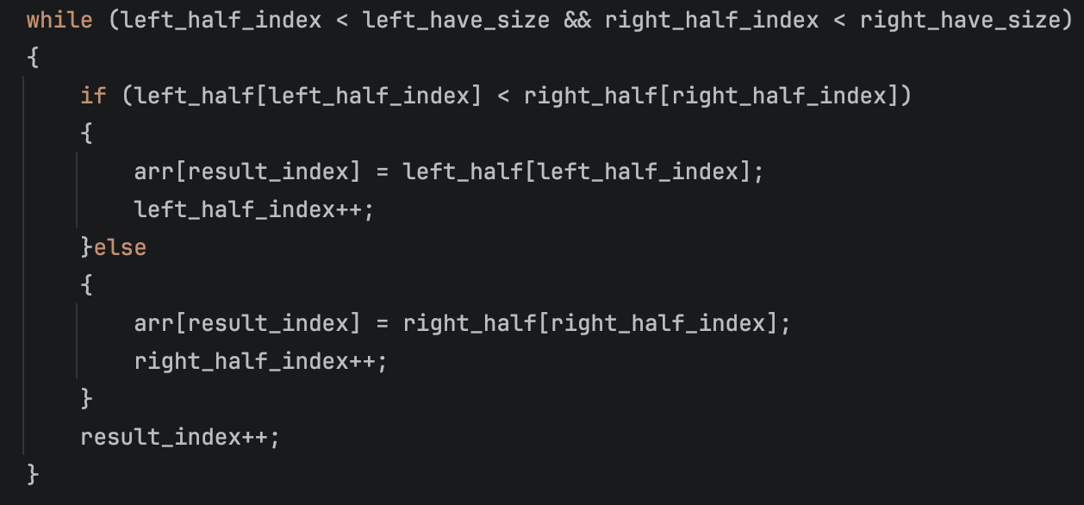

That means the when the left one equals to the right one, we would choose the right one priorly. In this case, <= is used to ensure the right one is always switched into left.

Evidence of Testing
Test | Screen Shoot
generic_sort.cpp | 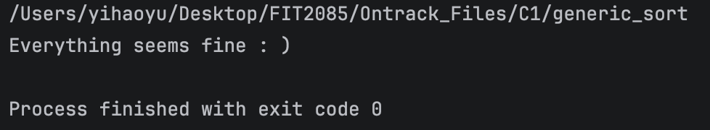
generic_linked_list.cpp  int test | 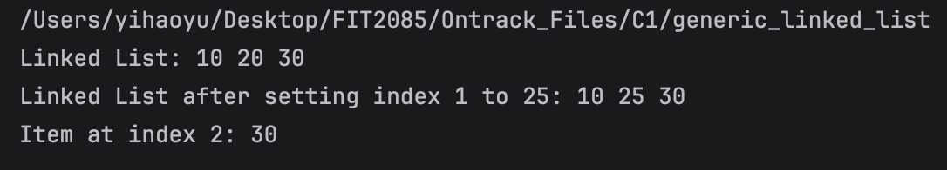
generic_linked_list.cpp  string test | 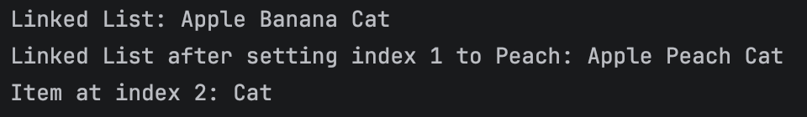
generic_linked_list.cpp  double test | 